**ASR 4716 Update container truck out and Reuse flag**

Date: 9 Sep 2014

Description:

1. Container - Update Container Truck-Out and Re-use Status screen. - 3
   1. **Add Truck # and company.**
2. Container Truck-out list - 2
3. Dashboard display containers status by ETA date, outstanding truck out containers. – pending -2

Updated change request: [19.09.2014]

1. Container Truck-in and Truck out update – add truck# and company name - 1
2. Print Gate pass by outbound ops. – for Empty truck out. - 2
3. Container status report – truck out / reused. - 2

Expected go live Mid Oct 2014

**WMS Changes:**

1. Container Truck-Out Update

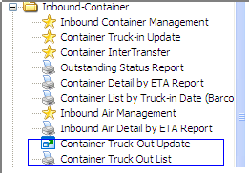

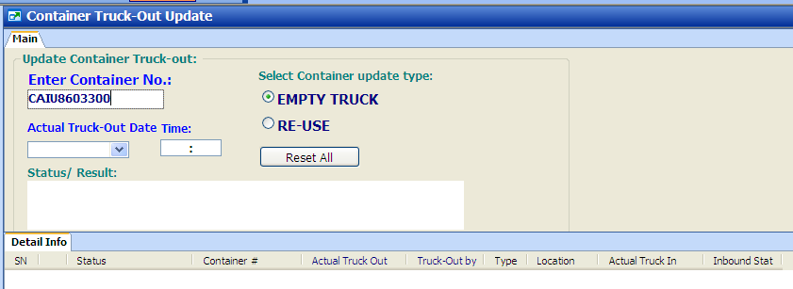

Select option to update:

Truck-out or Re-use

* 1. Select Container Update Type: “EPMTY TRUCK” or “RE-USE”

**UPDATE “EMPTY TRUCK” out**

* 1. Scan or input container #
  2. Press [ENTER]
  3. System default current system datetime as truckout date.
  4. Upon updated success, Status update: Trucked-out status updated

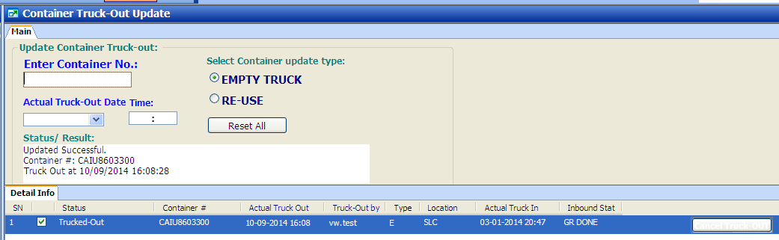

**UPDATE “RE-USE”**

1. Select “Re-Use”

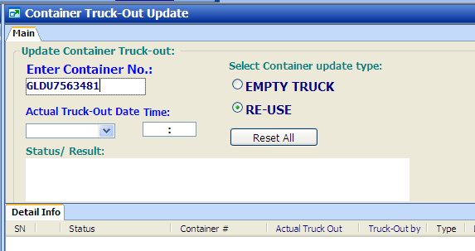

1. Scan or input Container no
2. Press [ENTER]
3. System update re-use flag
4. Successful update notice.

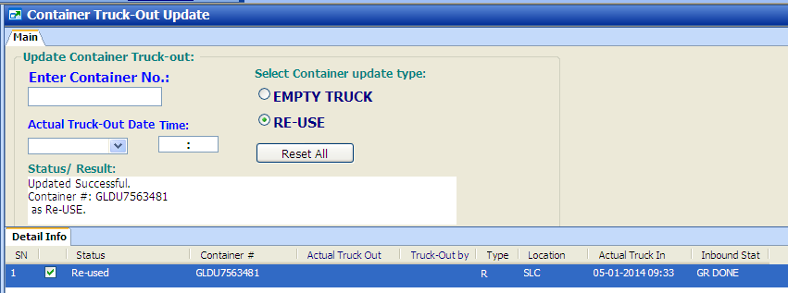

System validation:

1. IF error scanning duplicate container no:

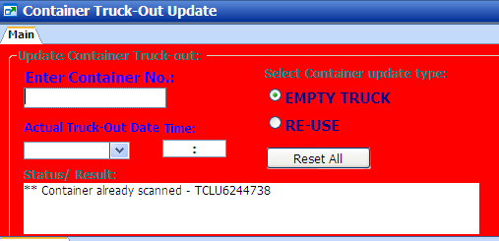

1. Container was updated empty trucked out.

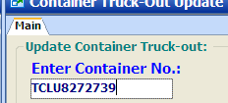

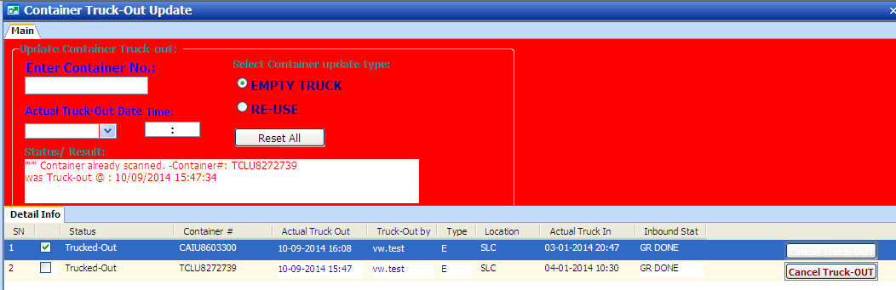

1. Container was updated as Re-used, not allow update EMPTY TRUCK out.

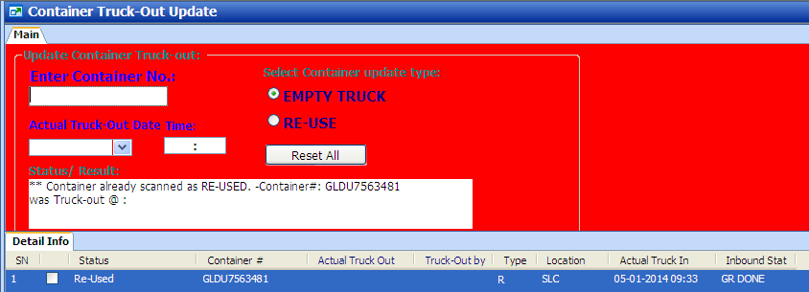

1. Container was updated as RE-USED, not allow duplicate update.

GLDU7563481

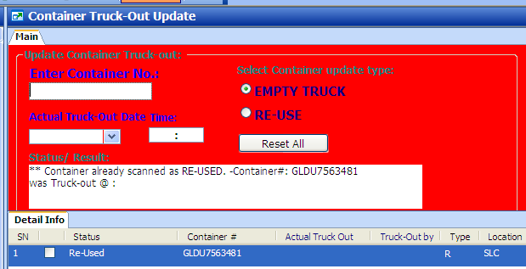

1. Container trucked out, not allow update RE-USED

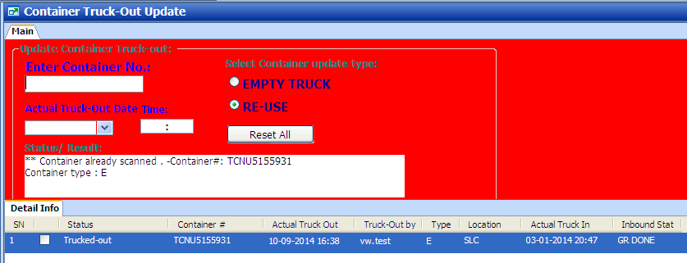



**Cancel Trucked Out:**

Click on button “Cancel Truck out” 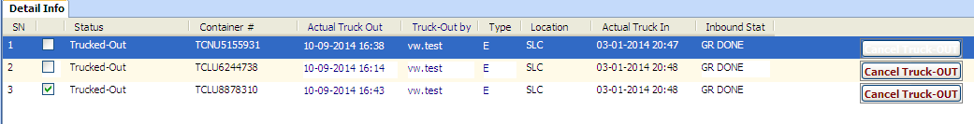

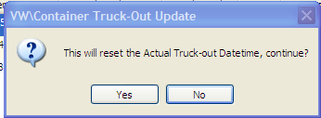

1. Report – Container truck-out List

Retrieve by Warehouse location (SLC. TLC or % (for all) )

And trucking schedule date

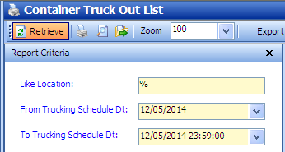

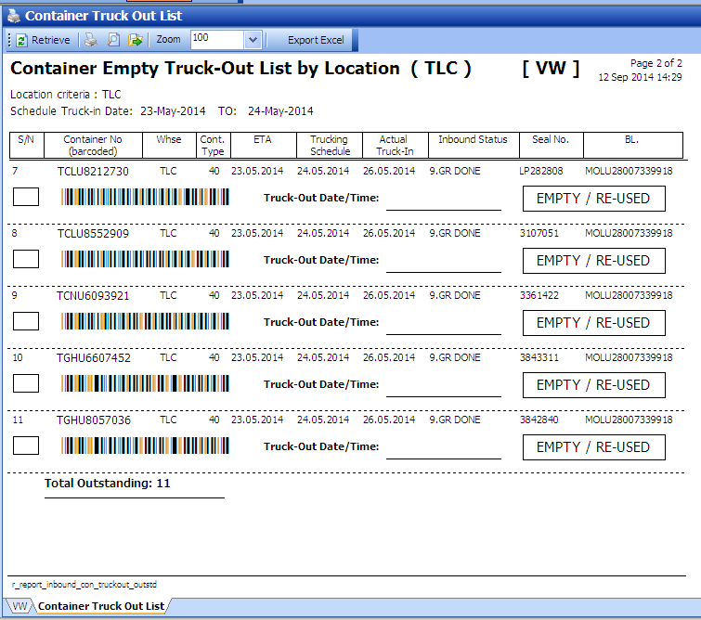

Tick for:

Empty Truck-out or Re-use

1. Dashboard – Container Truck-Out status by ETA